Linux Administration assignment 2 Day 5 Lets upgrade
Questions:
- Add a 10GB disk to the CentOS:
To add 10 GB disk
Click on the setting on the Virtual Machine,
Click on the hard disk then a window with add button will appear,
Click on add, follow the wizard by clicking hard disk, next, recommended disk type or choose the preferred type.
Select the disk to use.
Specify capacity in this case 10GB
Specify the file to store it the finish and press ok and the disk will be added as below.
Power on the system.
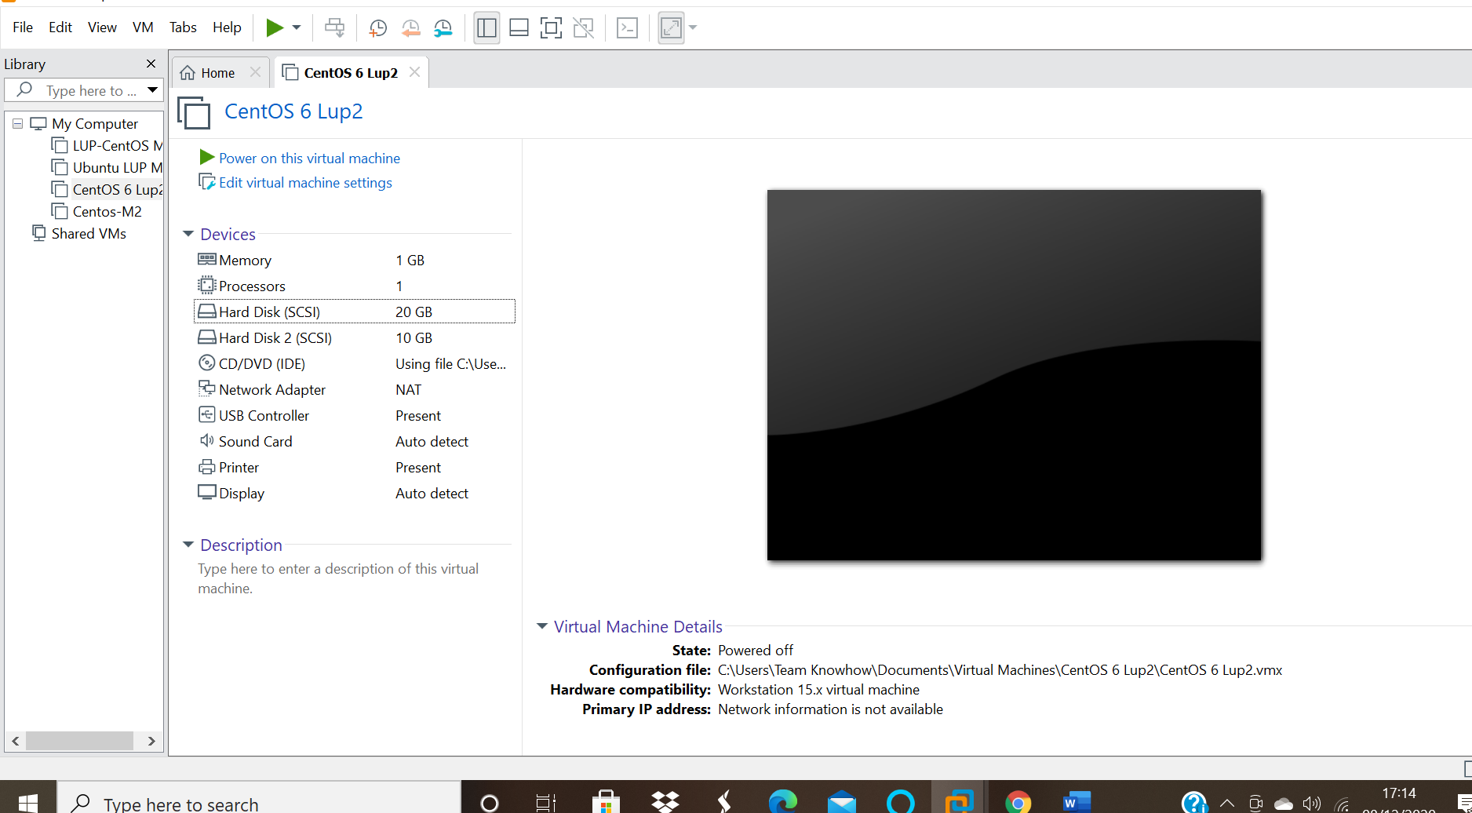

- Create 2 Partitions 4GB and 6GB of Space respectively.
- To partition the disk enter command fdisk /dev/sdc in this case I have used sdc since it’s the disk I am partitioning
- Press p to check if there are new partition,
- Then press n for new part and then p for primary partitioning.
- First partition first cylinder,enter +4GB
- Second Partition enter size as 6GB As Shown in the picture below.
Use command fdisk -l to check on the disks link as below.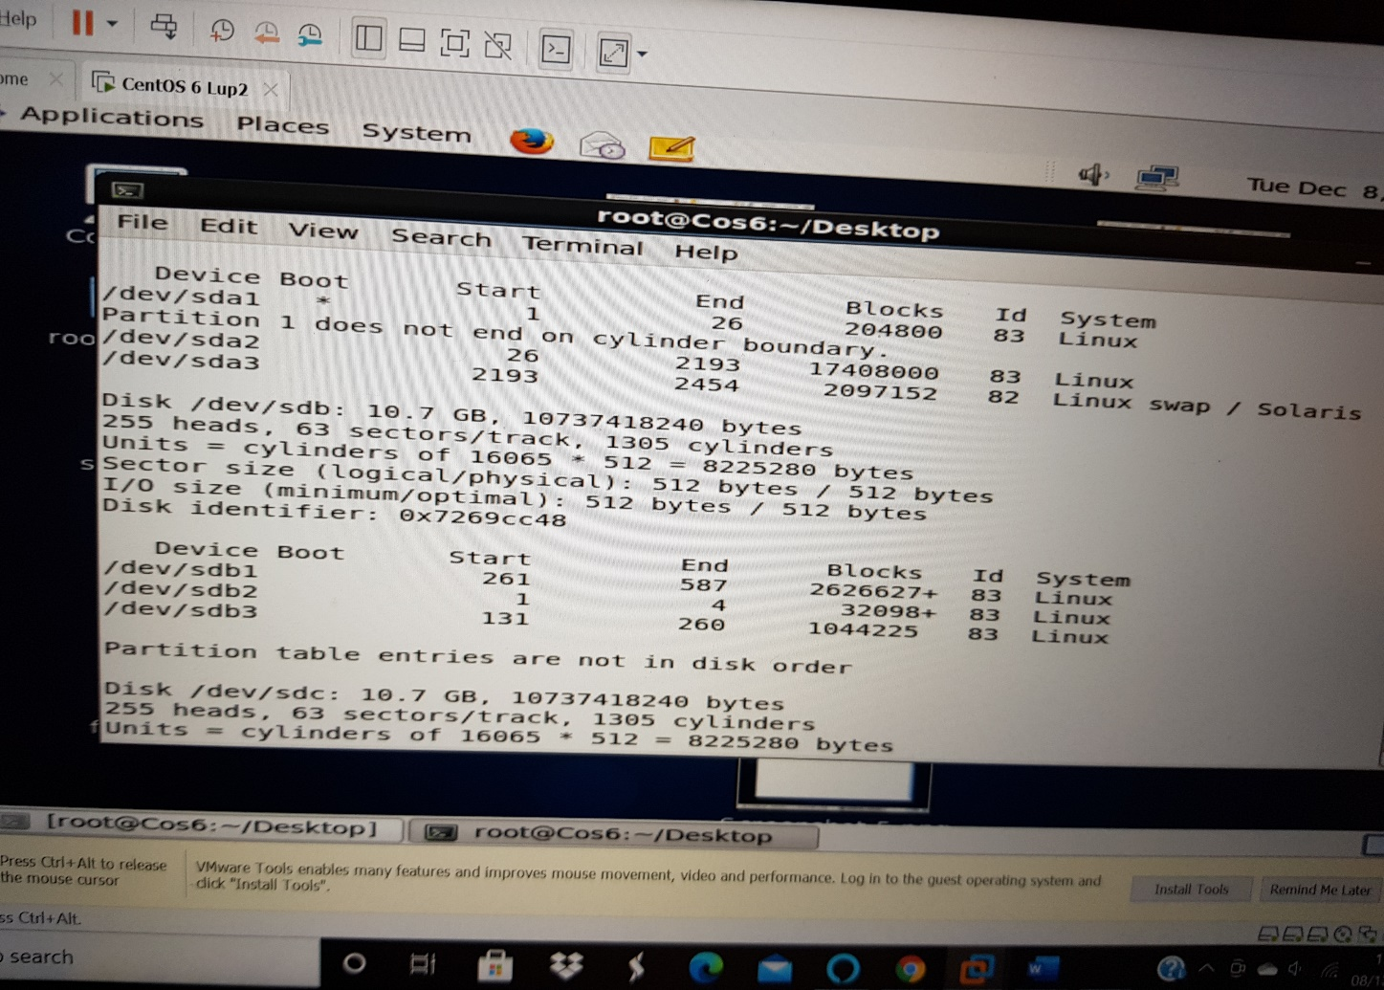Use command fdisk /dev/sdc to specify the disk you are partitioning as below: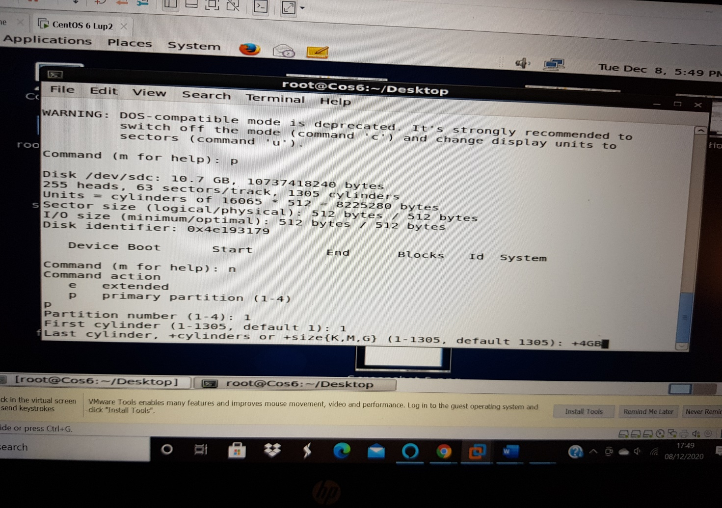

The picture below shows the result of first partitioning:
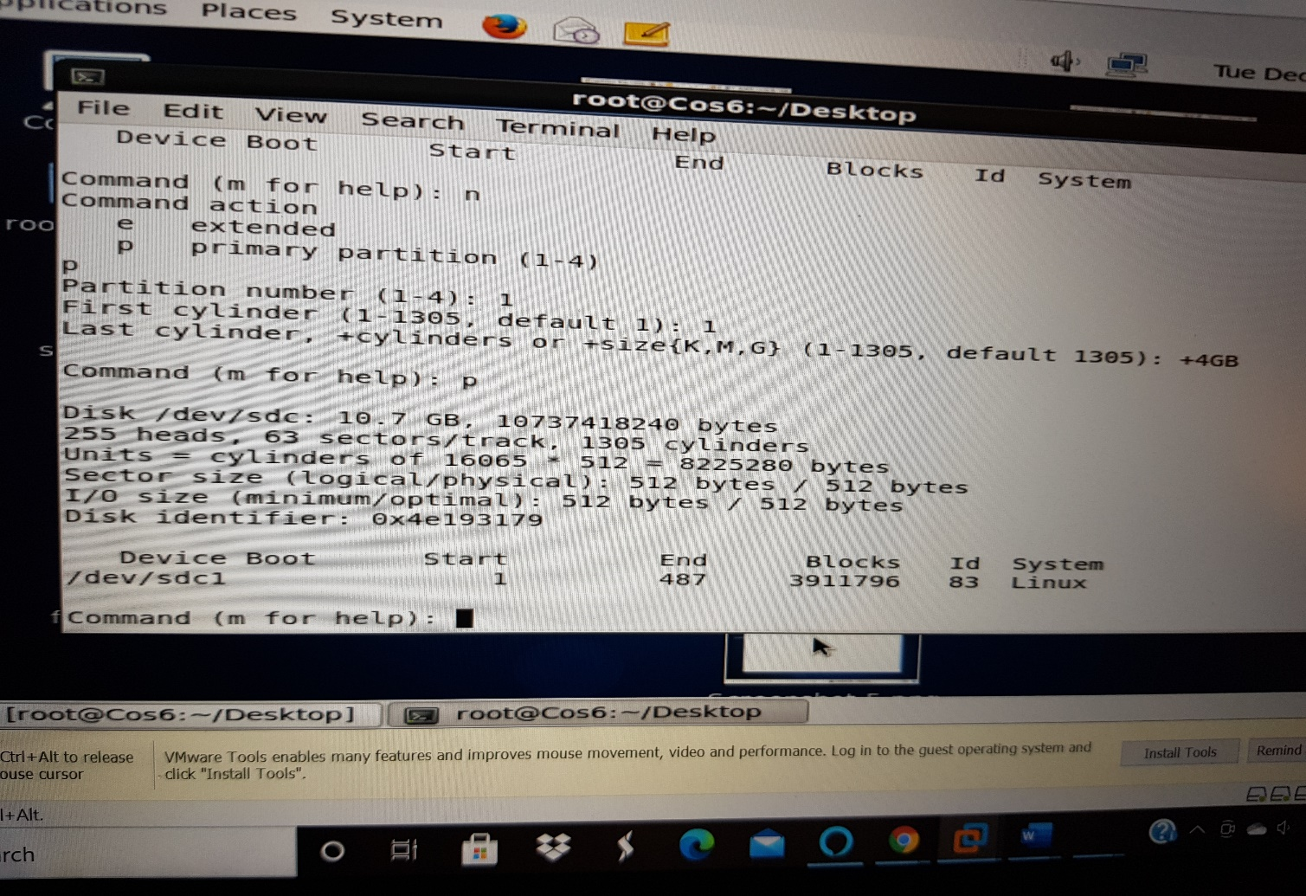

6GB Partitioning:
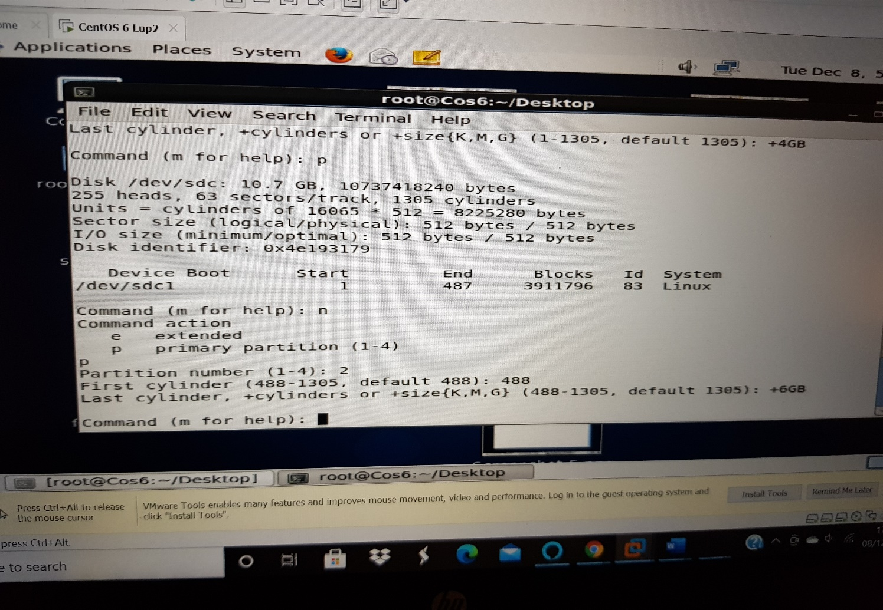

The two partitioning:
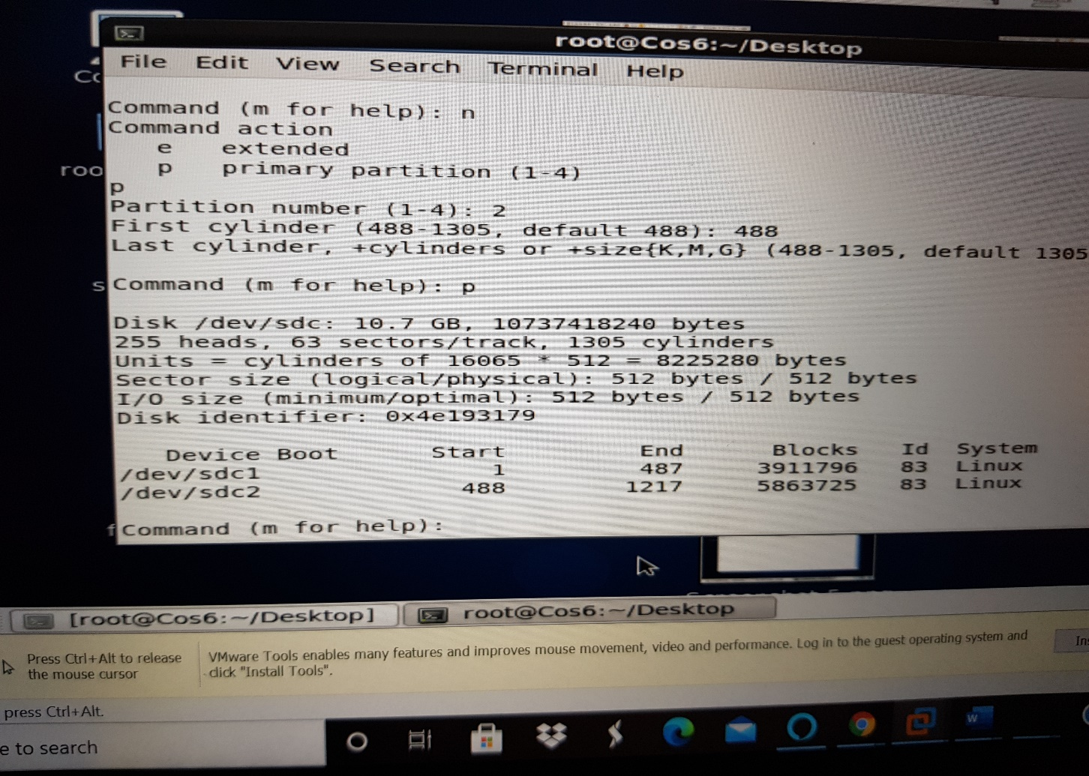
- Format 4GB with xfs and 6GB with ext4 file system.
To format with ext4 enter command mkfs.ext4 -j /dev/sdc2 ; 6GB is in the second partition hence sdc2.
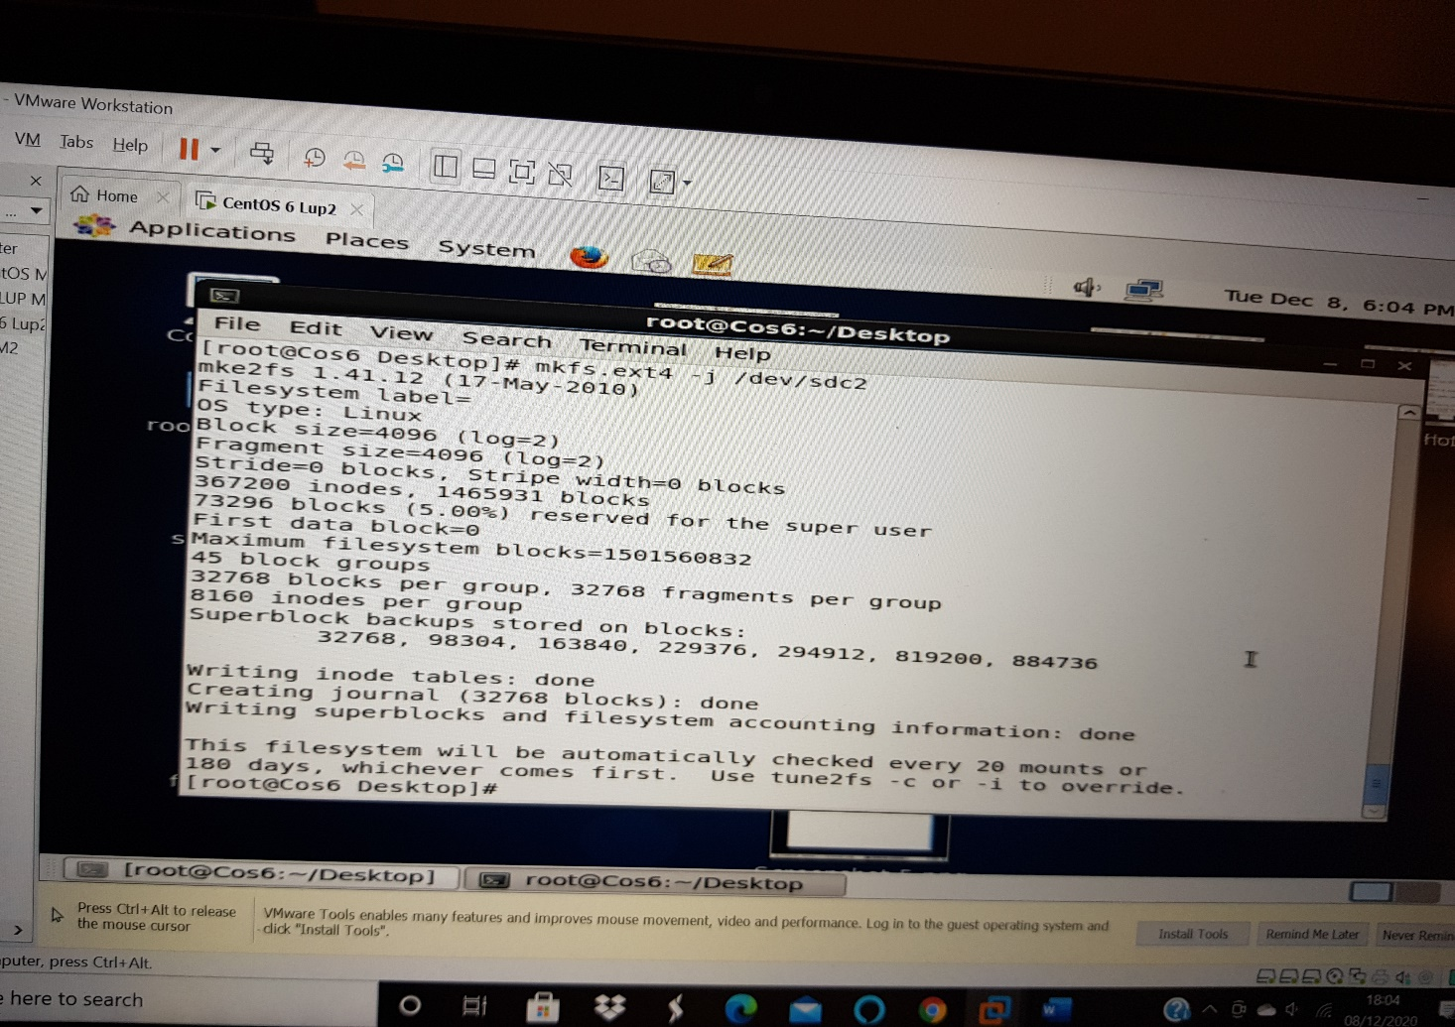

To format 4GB using xfs extension
- First install the package xfs
- By using command ls | grep xfs
- Then rpm -ivh (xfs file extension)
- There after format 4GB by entering command mkfs.xfs /dev/sdc1 (Used sdc1 since I partitioned it into 4GB).
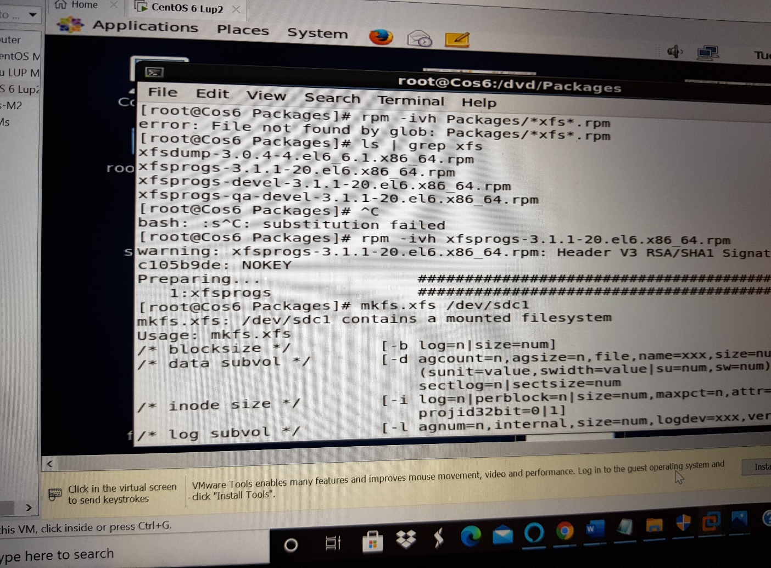

- Mount 4GB and 6GB in /data and /music directory respectively.
To mount the disk :
Use mount /sdc1 data for 4GB in this case sdc1
And mount /sdc2 /music for 6GB
Enter lsblk to see the details of the disk

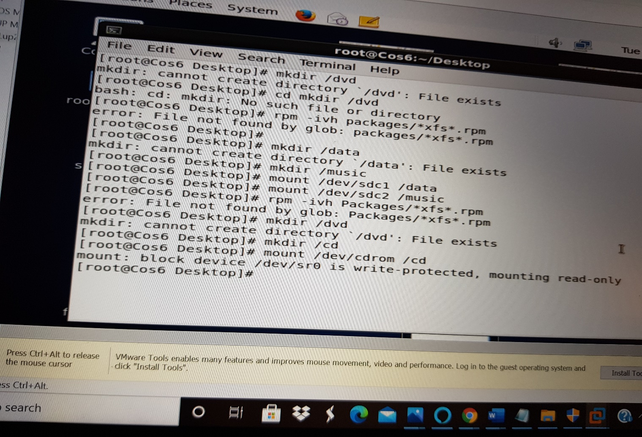
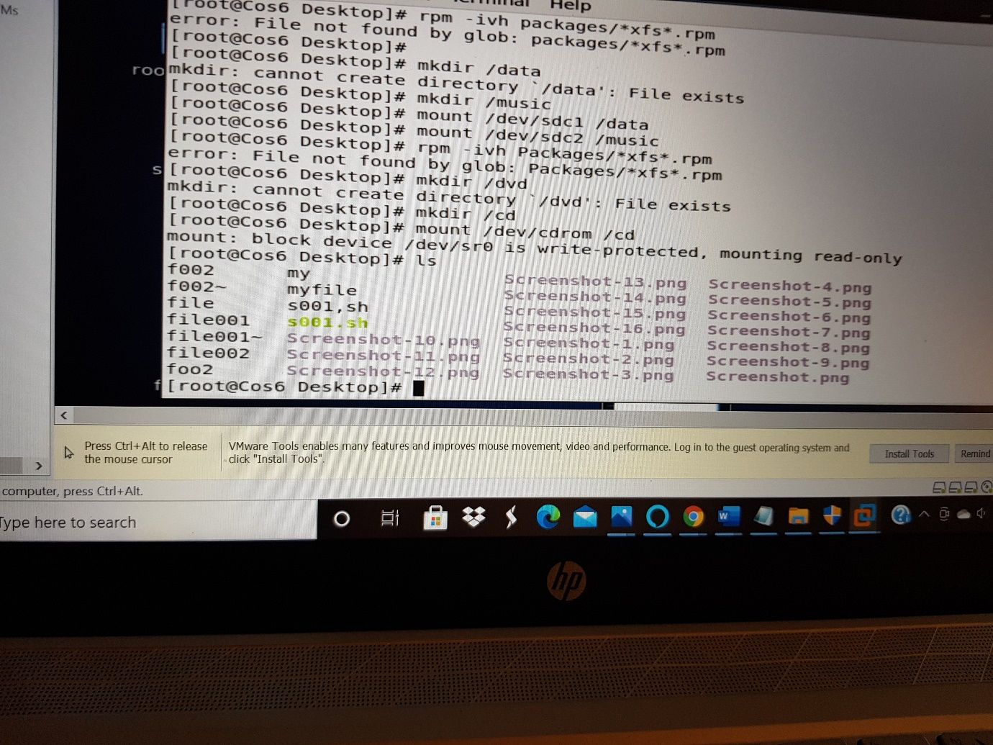

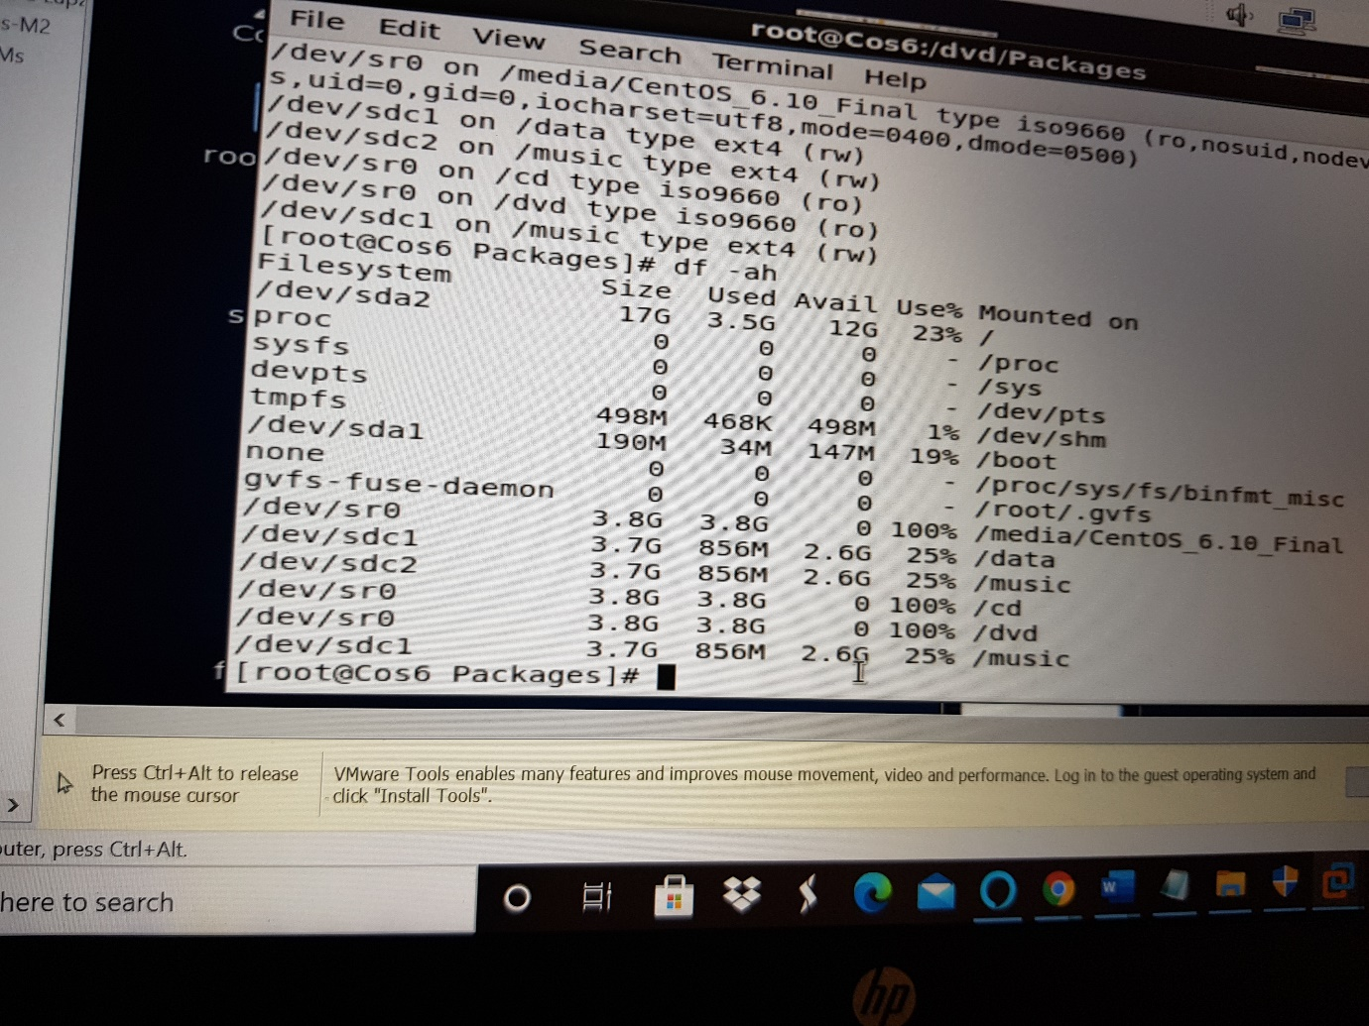

- Create one file of 1GB in each of the mount point created above.
To create a file we use command use command
Seq 100000000 > /data/SQ1
Seq 100000000 > /music/SQ2
Check the size using du -h /data/SQ1
And du -h /data/SQ2

6. Verify the disk Consumption and disk space free in the mounted partitions.
To verify the disk consumption and space use command, df -h


